(No Waste)
Software Design Document

Names:
Maryam Noureldin
Mennatallah Zaid
Marina Mikhael
Eman Abd Elhady
Farah Habib

Date: 10/14/2026 (version 1.1: 11/05/2026)

Table of Contents

1. Introduction

1.1 Purpose
1.2 Scope
1.3 Overview
1.4 Reference Material
1.5 Definitions and Acronyms

2. System Overview

3. System Architecture

3.1 Architectural Design
3.2 Decomposition Description
3.3 Design Rationale

4. Data Design

4.1 Data Description
4.2 Data Dictionary

5. Component Design

6. Human Interface Design

6.1 Overview of User Interface
6.2 Screen Images
6.3 Screen Objects and Actions

7. Requirements Matrix

8. Appendices

1. Introduction

1.1 Purpose
This Software Design Document (SDD) describes how NoWaste, a location-based mobile app that reduces food waste in Egypt, is built to satisfy the NoWaste Software Requirements Specification (SRS) version 1.1. It translates the SRS requirements into components, interfaces and data. Its readers are the team's developers and testers, and the course instructor and teaching assistants. This version (1.1) updates the preliminary design after Sprint 1, to match the code, SRS 1.1 and the TA and professor feedback. Detailed design follows in later sprints, and the document is updated every sprint.

1.2 Scope
The design covers:
• the mobile app used by consumers, vendors, charity and composting partners and administrators;
• a backend that serves them through a REST API, with a separate worker process for timed rules;
• a PostgreSQL database with the PostGIS extension for location queries, and object storage for photos;
• the external services the system calls: AI services (photo recognition, language model, speech), a payment gateway, a map service, a push notification service, and an email and SMS service.
It does not cover delivery of food, and nothing in the design certifies food as safe to eat. The design follows the SRS: every component traces to SRS functional requirements (Section 7), and the quality attributes in SRS Section 5 drive the architecture (Section 2.3).

1.3 Overview
This document follows a summary of IEEE Std 1016-2009.
• Section 2 gives the system overview, context and main design drivers.
• Section 3 gives the architecture: layers, five UML component diagrams, the component catalogue, interfaces, main interaction flows and the design rationale with patterns and alternatives.
• Section 4 describes the data and gives a data dictionary.
• Section 5 gives pseudocode for the components with the most important business rules.
• Section 6 describes the user interface.
• Section 7 traces each component to the SRS functional requirements and user stories.
• Section 8 lists technical risks and the appendices.

1.4 Reference Material
• Institute of Electrical and Electronics Engineers. (2009). IEEE standard for information technology—Systems design—Software design descriptions (IEEE Std 1016-2009).
• NoWaste Software Requirements Specification (SRS), version 1.1. Requirement IDs in this document (FR, E, NFR, BR, IF, TBD, US) refer to the SRS.

1.5 Definitions and Acronyms
Domain terms (listing, Discounted Surplus Bag, Donation, Compost offer, Quick Post, hold, waitlist, pickup code, perishability category, no-show, Zakat and others) are defined in SRS Appendix A and are used here with the same meaning. Terms used only in this document:
Term | Meaning
Adapter | A component that wraps one external service behind an interface, so the service can fail or be replaced without changing business logic
API | Application programming interface
Component | A replaceable part of the system with provided and required interfaces (C-nn)
Interface (Ixxx) | A named set of operations a component provides (ball) or requires (socket) in the UML component diagrams
JWT | JSON Web Token, the signed access token sent with every request
PostGIS | PostgreSQL extension for storing locations and calculating distances
RBAC | Role-based access control: what a user may do depends on their role
REST | Style of web API where the app requests resources over HTTPS
RTL | Right-to-left layout, used for Arabic
UML | Unified Modeling Language
Worker | The background process that runs time-based rules (C-19)

2. System Overview
NoWaste is a client-server system: one React Native app for all roles, and a modular-monolith backend with a separate worker. Vendors post surplus food, AI drafts the listing, and a routing recommender suggests the destination: discounted sale to nearby consumers, donation to charity, composting, or landfill as a last resort. The vendor confirms every AI result and chooses the destination; the perishability category and pick-by time come from rules kept in the database.

2.1 Architectural style
One cross-platform React Native app serves five roles (consumer, vendor, charity partner, composting partner, administrator) and shows each role its own screens. The app talks over HTTPS/REST to a single backend that is split into layers (API, application services, domain, data access) and into modules that match the six SRS features (4.1 to 4.6). The backend reaches each external service only through an adapter, so any of them can fail or be replaced without touching business logic. A separate worker process runs the time-based rules (holds, waitlist offers, automatic charity offers, uncollected Zakat refunds). Data lives in PostgreSQL with PostGIS; photos live in object storage.

2.2 Context
External party | Interaction | SRS
Consumer, vendor, charity partner, composting partner, administrator | Use the mobile app; what they see depends on their role | 2.3, 3.1
AI vision service | Classifies the food photo: food type, food category, estimated quantity, calorie range and a confidence value; drafts the listing in Arabic and English | 3.3, FR-LST-03, FR-LST-07
Language model service | Interprets typed or spoken (already transcribed) requests for the AI assistant | 3.3, FR-AST-01 to FR-AST-03
Speech service | Speech-to-text and text-to-speech in Arabic and English; keeps no audio | 3.3, NFR-11b
Payment gateway | Card payments, Zakat payments and refunds; card data never reaches NoWaste | 3.3, NFR-10
Map service | Map tiles drawn in the app; listing coordinates come from the backend | 3.3, FR-RES-01
Push notification service | Delivers notifications to Android and iOS devices | 3.3, FR-RES-11
Email and SMS service | Sends password-reset codes | 3.3, FR-ACC-05
Distances and "within 10 km" searches are calculated by PostGIS in the database, not by the map service (SRS 3.3, NFR-01).

2.3 Main design drivers
These SRS requirements shape the architecture most:
• NFR-03 Availability (fault tolerance): every AI service is optional. If it fails, vendors post by hand and consumers still search and reserve (E-LST-01, E-AST-02).
• NFR-05 Food safety: AI never certifies food. The vendor confirms every AI-filled field, the pick-by time worked out from the shelf-life rules caps the pickup window, and missing or uncertain information defaults to Highly perishable (FR-RTE-02).
• NFR-06, NFR-07 Arabic and accessibility: right-to-left layout and screen-reader support are built into the client from the first sprint.
• NFR-08 Low connectivity: NoWaste cannot control the network, so it keeps what it does control small and robust: photos compressed to 500 KB or less, small payloads, timeouts with retry, and a local cache of active reservations and pickup codes (E-RES-06).
• NFR-09, NFR-10, NFR-11 Security and privacy: RBAC in one place, salted password hashes, login rate limiting, card data only at the gateway, consumer location and voice recordings not stored.
• NFR-12 Availability: when the payment gateway, map, push, or email and SMS service is down, functions that do not need it keep working. Each service sits behind its own adapter for this reason.
• NFR-13, NFR-14 Maintainability and portability: automated tests on every merge with mocked adapters; one shared codebase for Android and iOS.
• Correct reservations: bags are never over-reserved (FR-RES-07, E-RES-02), and the timers in SRS 5.5 (45-minute hold, 20-minute check-in, 10-minute waitlist offer, 30-minute waitlist cut-off) fire reliably, even after a restart.
• NFR-15 Reliability: the same action gives the same result. The perishability category, pick-by time and destination ranking come from rules, with no randomness, and a reservation or payment request repeated after a dropped connection never creates a second one (Section 7.2).

2.4 Deployment view
The mobile app (Android and iOS) calls the backend API over HTTPS with TLS 1.2 or later (IF-COM-01). The backend API and the worker run as two processes from the same codebase. Both are restarted automatically on failure by the hosting platform, which detects a failed API through its health check (GET /health) and both use the same PostgreSQL database and object storage. GitHub Actions runs the automated tests on every merge (NFR-13). During the course the payment gateway runs in sandbox mode only (IF-SW-07). The backend framework is chosen (Node.js with TypeScript and Express); the service providers are still open (SRS TBD-2). Administrator accounts are created with a command-line seed script run by the team (SRS 2.7).

3. System Architecture
NoWaste is decomposed into 30 components (C-01 to C-30): the app, the API layer, 16 application services, the worker, 8 adapters, data access and two data stores. Two entry points receive all work: the API layer (requests from the app) and the worker (time-based jobs). Both call the same application services. Below them, the components are arranged in layers, and each layer calls only the layer below it.

3.1 Architectural Design

3.1.1 Layers
Layer | Components | Responsibility
Client | C-01 Mobile App, C-24 Map View | Screens for each role, local validation, Arabic and English with RTL, offline cache of active reservations, photo compression, speech capture and playback, map drawing
Entry points | C-02 API Layer, C-19 Scheduler / Worker | C-02 receives requests from the app: REST endpoints, authentication, RBAC, input validation, login rate limiting, and the health check. C-19 runs the time-based jobs in 5.5. Both call the same application services and hold no business rules.
Application services | C-03 to C-18 | One service per feature area; implements the SRS business rules and use cases
Domain | (inside the services) | Entities and rules shared by services: listing, reservation, hold, perishability category
Integration adapters | C-20 to C-23, C-25, C-26, C-30 | One adapter per external service behind an interface
Data access | C-27 Data Access | Repositories over PostgreSQL; transactions and row locking; no business rules
Data stores | C-28 PostgreSQL + PostGIS, C-29 Object Storage | Relational data and locations; photo files
Rule: the entry points call only the application services, and each layer below calls only the layer below it. Services never call an external service directly; they call adapter interfaces. The worker is an entry point, not a layer under the services, because it starts work on a timer the way the API starts work on a request. A third, team-only entry point, the admin seed script, creates administrator accounts from the command line (SRS 2.7); it is not part of the running system.The API layer may use shared domain types, such as the SRS error type and the role list, but no business rules.

3.1.2 UML component diagrams
The component diagram is split into five figures so each stays readable. Figure 1 shows the subsystems. Figures 2 to 4 show the backend services grouped by SRS feature. Figure 5 shows the adapters, external services and data stores. A ball is a provided interface and a socket is a required interface; a ball inside a socket means the component on the socket side depends on that interface. A white box marked "see Figure n" is drawn in full in another figure. Every service also requires IRepository (C-27); to keep the figures readable this is drawn only in Figures 1 and 5. External systems are drawn as UML components with the stereotype «external system» inside a dashed boundary named «external» Third-party services. The boundary marks what NoWaste does not own; each system inside it is reached only through its adapter. The dashed box "Entry points" in Figure 1 groups C-02 and C-19.

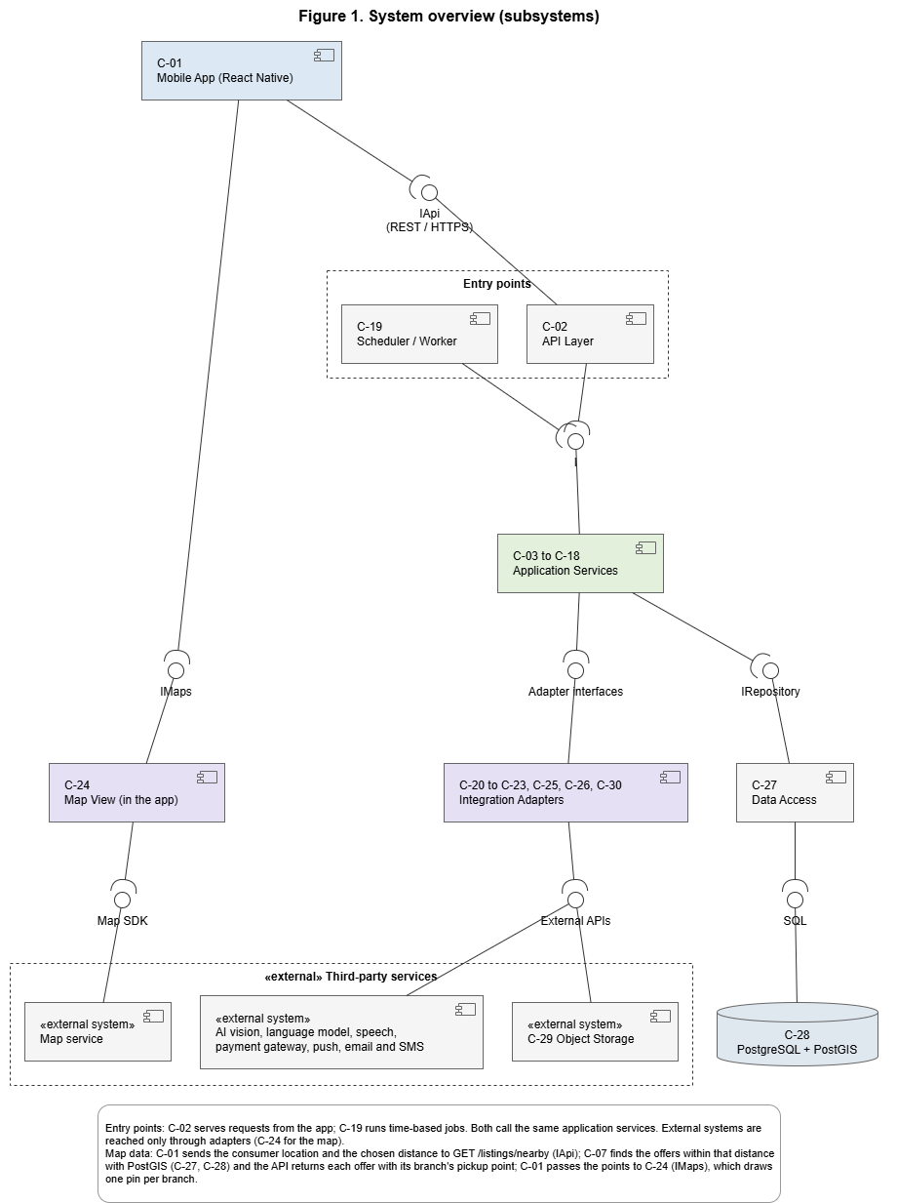

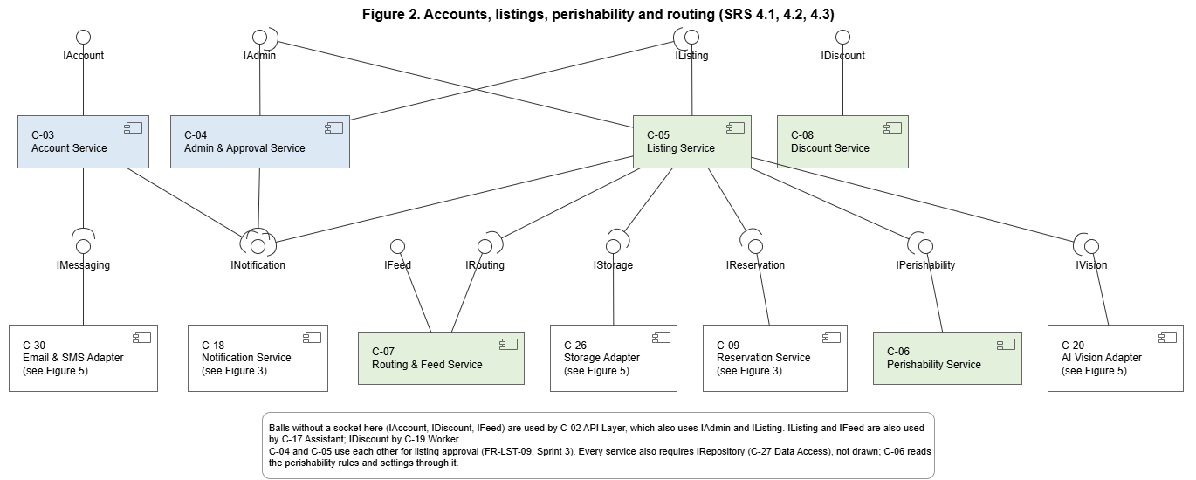
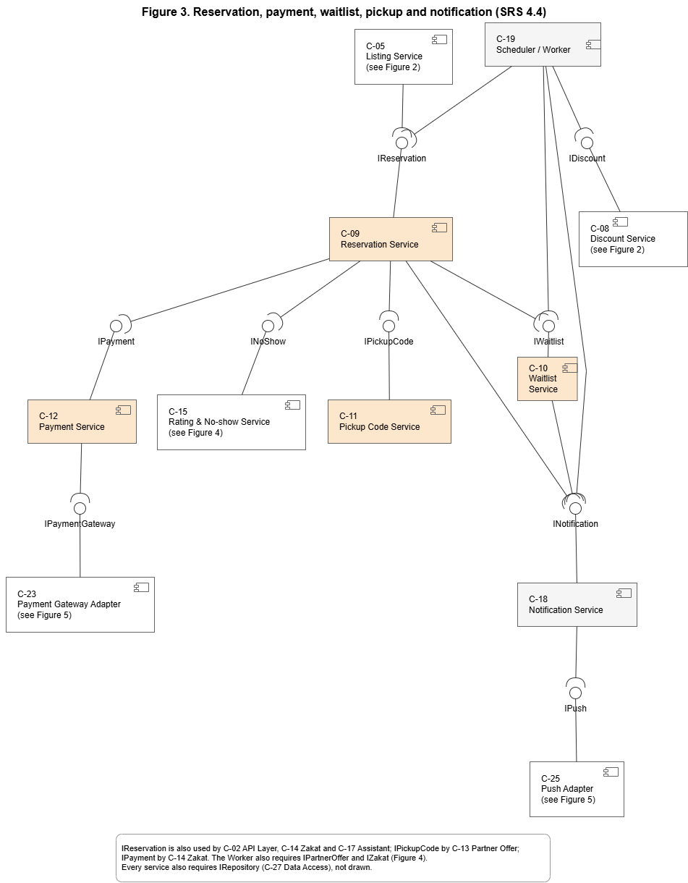

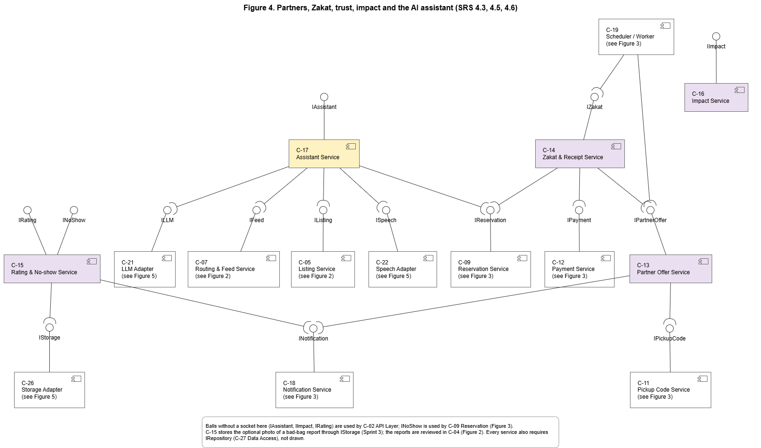
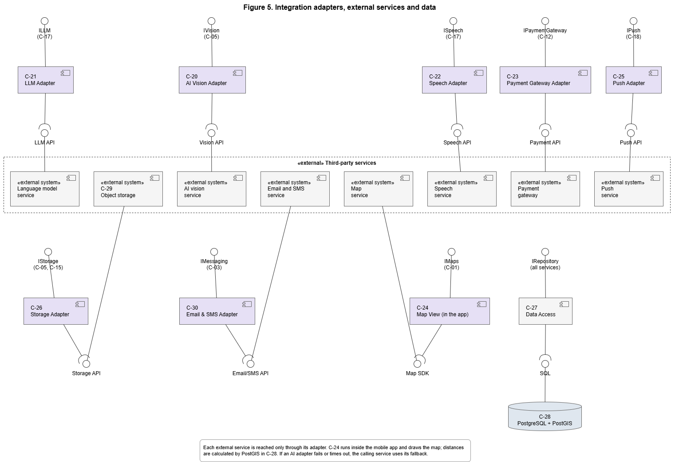

3.2 Decomposition Description

3.2.1 Component catalogue
ID | Component | Responsibility | Provides | Requires | SRS requirements
C-01 | Mobile App (React Native) | All screens for the five roles; input validation; Arabic and English with RTL; photo compression to 500 KB; cache of active reservations and pickup codes; speech capture and playback | Screens | IApi, IMaps | 3.1, IF-UI-01 to 08, NFR-06, NFR-07, NFR-08
C-02 | API Layer | REST endpoints over HTTPS; JWT sessions ended at logout; RBAC on every request; blocks Pending, Rejected and Suspended accounts; locks an account for 15 minutes after 5 failed logins; validates input with the shared validator package (@nowaste/shared) that the app also uses, so both apply the same rules; GET /health reports whether the API can reach the database, for the hosting platform's restart check | IApi | All service interfaces | FR-ACC-04, E-ACC-03, E-ACC-05, E-ACC-06, E-LST-06, IF-COM-01 to 04, NFR-09
C-03 | Account Service | Consumer registration by email or phone; vendor and partner applications (shop or organisation details, map pin and written address, accepted food types; for vendors the opening hours and further branches); login and logout; password reset by code; profile; language | IAccount | INotification, IMessaging | FR-ACC-01 to 06, FR-ACC-09, E-ACC-01, 02, 04
C-04 | Admin & Approval Service | Approve or reject applications; suspend or remove vendors and partners (revoke access, hide their listings); review accounts flagged for no-shows. Planned for Sprint 3: approve or reject every listing before it is published (US-50); manage the perishability rules and the business-rule settings (US-46, US-47); review bad-bag reports and warn or suspend the vendor (US-49) | IAdmin | INotification, IListing | FR-ACC-07, FR-ACC-08, FR-ACC-10, FR-ACC-11, FR-LST-09, FR-TGI-04 (review), FR-TGI-10
C-05 | Listing Service | Create full listings (formal vendors, at one of their branches) and Quick Posts (informal vendors, with an optional start and food category); keep the name and description as written; coordinate the AI draft and calorie estimate; work out and preview the pick-by time (with C-06) and accept an earlier end, inside the branch opening hours (E-LST-03, E-LST-04); keep the vendor's branches and opening hours; send every new listing for administrator approval (FR-LST-09, Sprint 3); publish only when every AI-filled field is confirmed; edit, cancel (cancelling reservations with full refunds) and view listings | IListing | IVision, IStorage, IPerishability, IRouting, IReservation, INotification, IAdmin | FR-LST-01 to 09, E-LST-01 to 07, NFR-05b, NFR-05c
C-06 | Perishability Service | Rule-based perishability category and pick-by time. The food limit is the pickup start plus the shelf-life of the food category and storage, read from the perishability rules table; the BR-01 limits are read from the settings table. The category counts the hours from the pickup start (from now once it has started) and is Highly perishable when information is missing, Unknown or uncertain. It is set when the listing is saved; the vendor does not change it | IPerishability | IRepository (rules and settings) | FR-RTE-01 to 03, E-RTE-01, NFR-05d
C-07 | Routing & Feed Service | Ranks destinations (consumers, charity, composting, landfill) by distance, time left, food category and partners' accepted food types and returns the top one; sets the listing type; unfit food to composting only; consumer feed: finds Active listings whose pickup branch is within the chosen distance of the consumer (10 km by default, 1 to 50 km, from the FR-RES-01 settings row; PostGIS), puts Highly perishable listings nearby first, then by distance and time left, and returns each listing with its branch and pickup point for the map, without the perishability category (FR-RTE-04); map filters; Ramadan mode highlighting | IRouting, IFeed | none (PostGIS queries through IRepository) | FR-RTE-04 to 09, E-RTE-02, FR-RES-01, FR-TGI-08
C-08 | Discount Service | Rule-based discount suggestion that rises as the pickup deadline nears while bags are unreserved; the vendor chooses whether to apply it | IDiscount | none | FR-LST-08
C-09 | Reservation Service | One bag per reservation; card reservation confirmed only after payment approval and held for the whole window; no-card hold of 45 minutes from the later of reservation time or window start, capped at window end; one 20-minute check-in; cancellation and refund decision; release of bags; no over-reservation | IReservation | IPayment, IPickupCode, IWaitlist, INoShow, INotification | FR-RES-02 to 09, FR-RES-12, E-RES-01 to 05, BR-02 to 06
C-10 | Waitlist Service | Queue per fully reserved listing; offer a released bag only if 30 or more minutes remain; 10 minutes to accept; then the next person or back to the vendor | IWaitlist | INotification | FR-RES-05, FR-RES-06, BR-04, BR-05
C-11 | Pickup Code Service | Issue and verify 6-digit codes for consumer reservations, Donation and Compost pickups; mark the handover Completed | IPickupCode | none | FR-RES-10, E-RES-03, BR-09
C-12 | Payment Service | Start and confirm card payments and refunds through the gateway adapter; never stores card data | IPayment | IPaymentGateway | FR-RES-02, FR-RES-12, FR-TGI-05, E-LST-05, E-RES-01, E-TGI-02, NFR-10
C-13 | Partner Offer Service | Offer Donations and Compost offers to partners that accept the food type; accept and schedule a pickup within the window; first acceptance wins; partner cancellation and re-offer; automatic charity offers; landfill records | IPartnerOffer | IPickupCode, INotification | FR-RTE-10 to 13, E-RTE-03, E-RTE-04
C-14 | Zakat & Receipt Service | Card-paid bag donated as Zakat to a chosen charity that accepts the food type; the bag becomes a Donation; traceable receipt; full refund if not collected | IZakat | IReservation, IPayment, IPartnerOffer | FR-TGI-05, FR-TGI-06, E-TGI-02, E-TGI-03, BR-11
C-15 | Rating & No-show Service | Ratings and reviews once per Completed reservation; vendor no-show flags after the window; no-show counting; admin flag at 3 in 30 days; 14-day no-card block; consumers' bad-bag reports (US-48, Sprint 3) | IRating, INoShow | INotification, IStorage | FR-TGI-01 to 04, FR-TGI-09, FR-RES-13, E-TGI-01, BR-07, BR-08
C-16 | Impact Service | Meals rescued, money saved (original value minus price paid), estimated CO2 avoided, bags composted and bags sent to landfill; platform-wide and per user | IImpact | none | FR-TGI-07
C-17 | Assistant Service | Interprets typed or spoken requests in Arabic or English; returns the same results as the map search; answers questions, read aloud on request; repeats the reservation and acts only after confirmation; card payment goes to the normal payment screen; vendor help | IAssistant | ISpeech, ILLM, IFeed, IListing, IReservation | FR-AST-01 to 04, E-AST-01, E-AST-02
C-18 | Notification Service | Builds and sends push notifications: reservation confirmed, released, waitlist offer, pickup window open, application decision, listing changed or cancelled, account suspended, flagged account for the admin, partner pickup scheduled | INotification | IPush | FR-RES-11, FR-ACC-07, FR-ACC-08, E-LST-05, IF-SW-06
C-19 | Scheduler / Worker | Entry point for time-based jobs, beside C-02 (see 3.1.1).  Expires holds and records no-shows; runs waitlist offer timers; raises the discount suggestion; sends the window-open notification; makes automatic charity offers (at the time the administrator sets, TBD-5); asks the vendor to record landfill at window end; refunds uncollected Zakat donations | none (calls services) | IReservation, IWaitlist, IDiscount, INotification, IPartnerOffer, IZakat | FR-RES-05, FR-RES-11, FR-RES-13, FR-LST-08, FR-RTE-11, FR-RTE-13, E-TGI-03
C-20 | AI Vision Adapter | Wraps the AI vision API: food type, category, quantity, calorie range, confidence, draft text; 10-second time limit | IVision | Vision API | FR-LST-03, FR-LST-07, E-LST-01, NFR-02
C-21 | LLM Adapter | Wraps the language model API | ILLM | LLM API | FR-AST-01 to 04
C-22 | Speech Adapter | Speech-to-text and text-to-speech in Arabic and English; deletes audio after processing | ISpeech | Speech API | FR-AST-01, FR-AST-02, NFR-11b
C-23 | Payment Gateway Adapter | Wraps gateway charge and refund calls; sandbox mode during the course | IPaymentGateway | Payment API | NFR-10, IF-SW-02, IF-SW-07
C-24 | Map View (in the app) | Wraps the map SDK in the app. Receives from C-01 the pickup points that GET /listings/nearby returned and draws one pin per pickup branch on the map service's tiles, zoomed to the chosen distance; a tapped pin shows the store name, the branch address and that branch's offers. Without a location it centres on central Cairo. Also the pin picker for the shop, branch or partner location (US-02, US-03). It does not search, store or rank listings. | IMaps | Map SDK | FR-RES-01, 3.3 Map service
C-25 | Push Adapter | Sends to Android and iOS push services | IPush | Push API | FR-RES-11
C-26 | Storage Adapter | Stores and fetches compressed photos | IStorage | Storage API | FR-LST-01, E-LST-02
C-27 | Data Access | All reads and writes to PostgreSQL; transactions; row locking; PostGIS distance queries | IRepository | SQL | FR-RES-07, E-RES-02, IF-COM-06
C-28 | PostgreSQL + PostGIS | Relational data, locations and distance indexes | SQL | none | NFR-01
C-29 | Object Storage | Photo files | Storage API | none | FR-LST-01
C-30 | Email & SMS Adapter | Sends password-reset codes by email or SMS | IMessaging | Email/SMS API | FR-ACC-05, E-ACC-04

3.2.2 Generalization and lifecycles
• Users: User → Consumer, Vendor (Formal, Informal), Partner (Charity, Composting, Other), Administrator. Administrator accounts are created by the team (SRS 2.7).
• Listings: Listing → Discounted Surplus Bag, Donation, Compost offer. The type is set by the destination the vendor chooses (FR-RTE-06). Quick Post is a way of creating a listing, not a type: a Quick Post becomes a Discounted Surplus Bag that is always Highly perishable (FR-LST-02); after posting, the vendor may send it to a charity or composting partner instead until the pickup ends.
• Account states: Pending → Approved or Rejected (vendors and partners); Approved → Suspended or Removed (FR-ACC-07, FR-ACC-08).
• Listing states: Draft → Pending review (administrator approval, Sprint 3) → Active → Fully reserved ↔ Active → Closed; Pending review → Rejected; or Cancelled by the vendor (FR-LST-05, FR-LST-09). A Quick Post starts at Pending review.
• Reservation states: Pending payment → Confirmed (card) or Held (no-card) → Completed, Released, Cancelled or No-show.
• Partner offer states: Offered → Accepted (pickup scheduled) → Completed; Accepted → Offered again when a partner cancels; Offered → Landfill recorded when no one takes the food.

3.2.3 Key interfaces
Interface | Main operations
IApi (REST) | Built in Sprint 1: GET /health; POST /auth/register, POST /auth/login, POST /auth/logout; GET and PATCH /users/me; GET /admin/applications, POST /admin/applications/{userId}/approve and /reject; GET and PATCH /vendors/me, POST /vendors/me/branches, PATCH /vendors/me/branches/{id}; POST /listings/photo, POST /listings/pick-by, POST /listings, POST /listings/quick, GET /listings, GET /listings/{id}, GET /listings/{id}/photo, POST /listings/{id}/perishability/estimate, GET /listings/{id}/destinations, POST /listings/{id}/destination, POST /listings/{id}/unfit, POST /listings/{id}/publish; GET /listings/nearby, GET /listings/nearby/{id}, GET /listings/nearby/{id}/photo; GET /perishability/categories. Planned: POST /reservations (with an idempotency key), POST /reservations/{id}/checkin, POST /pickups/verify, POST /zakat, POST /assistant/message, and the administrator endpoints for listing approval, rules, settings and bad-bag reports.
IMaps (in the app) | showPins(places: branch key, store name, latitude, longitude) ; centreOn(location, radiusKm) ; onPinSelected(placeKey) → C-01 shows that branch's offers
IVision | classify(photo) → {foodType, foodCategory, quantity, calorieRange?, draftTextAr, draftTextEn, confidence}
IPerishability | estimate(foodCategory?, storage?, pickupStart, isQuickPost, aiConfident) → {category} ; pickBy(same inputs, branch closing time) → latest pickup end ; categoryHours() → {highlyPerishableMaxHours, shortLifeMaxHours}
IRouting | recommend(listing) → ranked destinations with the top one marked; setListingType(listingId, destination)
IFeed | nearby(consumerLocation, radiusKm, filters, ramadanMode) → {radius, offers in feed order, each with its id, name, price, pickup window, distance and place (branch, store name, address, latitude, longitude)} ; offer(id) → one offer for the product page
IReservation | reserve(listingId, consumerId, method, idempotencyKey), checkIn(id), cancel(id), releaseExpired()
IWaitlist | join(listingId, consumerId), offerNext(listingId), accept(offerId), expireOffer(offerId)
IPickupCode | issue(reservationOrOfferId), verify(code, vendorId) → Completed or error
IPayment / IPaymentGateway | charge(amount, token) → approved or declined; refund(paymentId, amount)
IPartnerOffer | offer(listingId), accept(offerId, partnerId, pickupTime), cancel(offerId), recordLandfill(listingId)
IZakat | donate(listingId, consumerId, charityId), markDelivered(id), refundUncollected()
INoShow | record(reservationId, source), countLast30Days(consumerId), isBlocked(consumerId)
INotification | send(userId, type, payload)
IMessaging | sendCode(emailOrPhone, code)
IAdmin | approve(applicationId), reject(applicationId) ; suspend(userId), remove(userId) ; planned: approveListing(listingId), rejectListing(listingId, reason), setShelfLife(foodCategory, storage, hours), setSetting(key, value), reviewReport(reportId, action)
IRepository | Repository per entity: get, save, query, lockForUpdate

3.2.4 Main interaction flows
1. Create a listing: App → API → Listing Service → Storage Adapter (photo) and Vision Adapter (draft within 10 seconds, else manual entry) → vendor confirms or edits and chooses the branch and pickup start → Listing Service asks the Perishability Service for the pick-by time and category (shelf-life rules, branch closing time) and the app shows the allowed window → vendor saves (Draft, category set) → Routing Service (top destination) → vendor chooses → Pending review → administrator approves (Sprint 3) → listing Active.
2. Card reservation: App → API → Reservation Service locks the listing row and reserves one bag → Payment Service → gateway → approved: confirm, issue pickup code, notify; declined: release the bag (E-RES-01).
3. No-card hold expiry: Worker → Reservation Service releases the bag and records a no-show → Waitlist Service (only if 30 or more minutes remain) → Notification Service → 10-minute offer timer → next person, or the bag returns to the vendor.
4. Donation pickup: Charity partner accepts a Donation and proposes a time → Partner Offer Service checks it is within the window → pickup scheduled, vendor notified, pickup code issued → vendor enters the code at handover.
5. Zakat donation: Consumer chooses Donate as Zakat and a charity → Zakat Service reserves the bag, takes card payment, turns the bag into a Donation for that charity and issues a receipt → charity collects with the pickup code → receipt updated; if not collected by window end, the Worker refunds in full.
6. Assistant reservation: App → Assistant Service → Speech and LLM adapters → search through IFeed → repeats listing, price, window and method → consumer confirms → Reservation Service (same rules as the screens); card payment opens the normal payment screen.
7. Browse on the map: App reads the GPS location (IF-HW-03; if permission is denied, it explains why and centres on central Cairo, IF-HW-04) → API GET /listings/nearby with the location, the chosen distance and filters (consumer role checked) → Routing & Feed Service (IFeed) → Data Access runs one PostGIS query for Active listings whose pickup point is within the chosen distance (10 km by default, from the FR-RES-01 settings row), using the spatial index (NFR-01) → Routing & Feed orders them (Highly perishable nearby first, then distance and time left) → API returns each listing's id, name, price, pickup window and place (branch, store name, address, latitude, longitude), without the perishability category; the consumer location is not stored (NFR-11a) → App passes the points to Map View (IMaps) → Map View draws one pin per branch on map tiles from the map service → tapping a pin shows that branch's offers, and an offer opens the product page (GET /listings/nearby/{id}). The map service only supplies tiles; it never stores, searches or ranks listings.
3.2.5 Story walkthroughs
This section follows five user stories through the components, one step at a time. Each step names the component that acts and the interface it uses, so the path from the screen to the database or an external service can be checked against Figures 1 to 5. Together the five stories pass through every layer: the app, both entry points (C-02 API and C-19 Worker), the services, the adapters, data access and the external systems. Three of them are drawn as UML sequence diagrams.

UML notation used
Symbol | Name | Meaning
Stick figure | Actor | App user (Vendor or Consumer).
Box + dashed line | Lifeline | Component (instance : type); time flows downward.
«external system» box | External lifeline | Third-party service (payment, maps, etc.).
Thin vertical bar | Activation bar | Component is processing a call.
Solid arrow (filled head) | Synchronous message | Caller waits for a response.
Dashed arrow (open head) | Reply message | Returns a response to the caller.
Solid arrow (open head) | Asynchronous message | Sent without waiting for a response.
Loopback arrow | Self message | Component calls its own operation.
alt frame | Alternative fragment | One branch executes based on a condition.
break frame | Break fragment | Executes if condition is true; skips remaining steps.
Folded-corner box | Note | Additional explanation, not a message.

3.2.5.1 Register and log in (US-01, US-04)
Register (US-01)
1. The consumer enters an email address or phone number and a password in C-01 Mobile App. The app checks the fields with the same validation rules the server uses (shared package).
2. C-01 sends POST /auth/register to C-02 API Layer [IApi].
3. C-02 checks the input and calls C-03 Account Service.
4. C-03 checks that the email or phone is not already registered (E-ACC-01), stores only a salted hash of the password (NFR-09b), and saves the user through C-27 Data Access [IRepository]. A consumer account is Active at once; vendor and partner applications stay Pending until C-04 Admin & Approval approves them (FR-ACC-02, FR-ACC-03).
Log in (US-04)
1. The user enters an email or phone number and the password; C-01 sends POST /auth/login [IApi].
2. C-03 reads the lockout limits from the Settings table (NFR-09d) and the recent failed attempts from LoginAttempt through C-27.
3. If the account is locked, C-03 refuses without counting the attempt; if the password is wrong, it records a failed attempt. In both cases C-02 returns E-ACC-03, with the same message for every wrong credential.
4. Otherwise C-03 records a Session and returns a signed access token. C-01 stores the token securely and sends it with every later request; C-02 checks the token and the role on every request (IF-COM-03, IF-COM-04).
5. Log out (POST /auth/logout) ends the Session, so the token stops working.

3.2.5.2 Create and publish a listing (US-10, US-18, US-19)
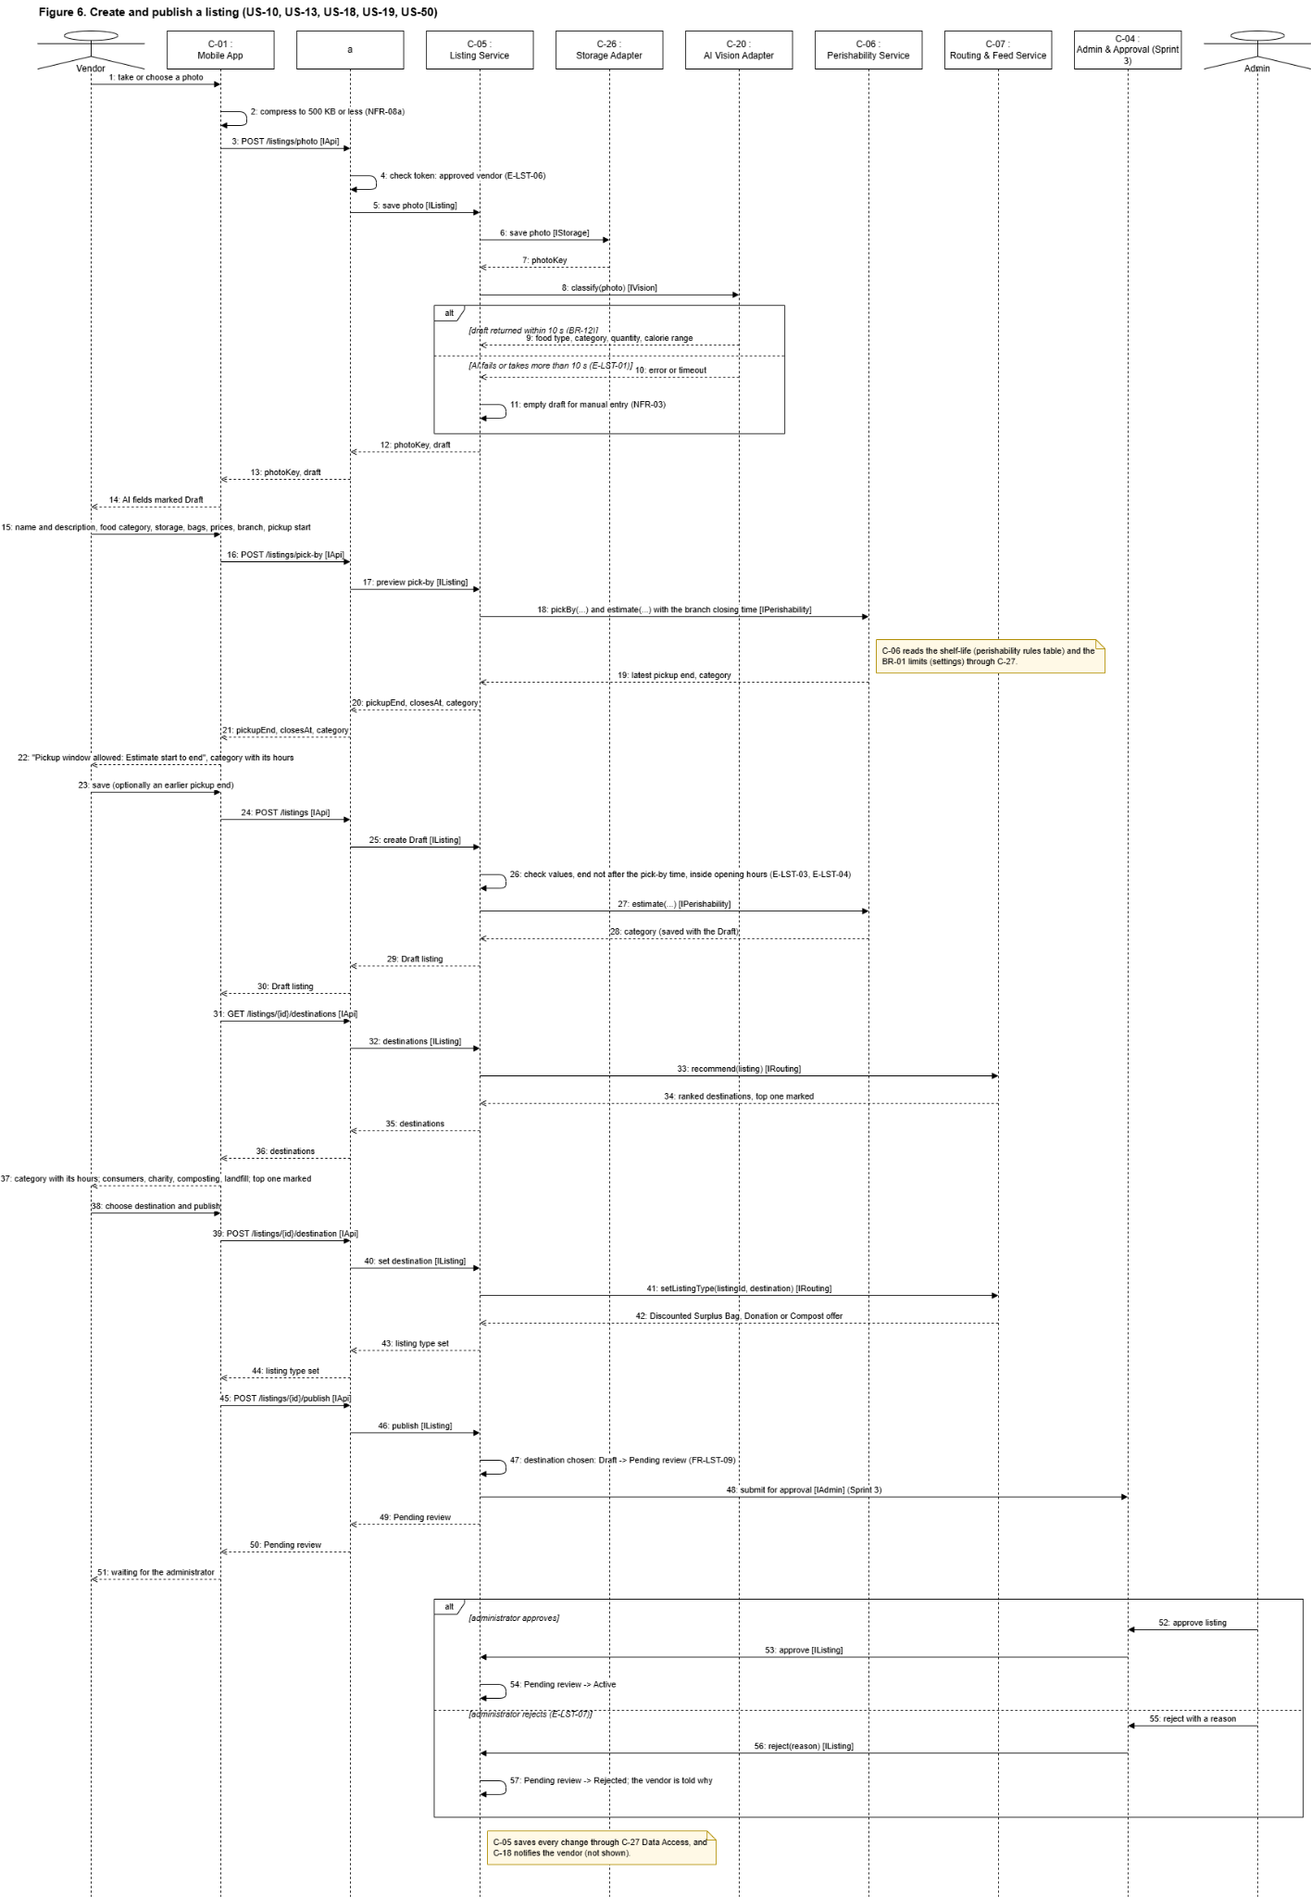
Figure 6. Create and publish a listing (US-10, US-18, US-19): the Listing Service coordinates storage, the AI draft, the pick-by time and category, the routing choice and the administrator approval.

The app uploads the compressed photo with POST /listings/photo; the Listing Service stores it through the Storage Adapter and asks the AI Vision Adapter for a draft, or the vendor fills the form by hand if the AI fails or takes more than 10 seconds (E-LST-01). While the vendor fills the form, POST /listings/pick-by asks for the allowed pickup window: the Perishability Service adds the shelf-life of the food category and storage (perishability rules table) to the pickup start, caps it at the branch's closing time and returns the category as the reason. POST /listings saves the listing as a Draft with that category; the vendor may choose an earlier pickup end (E-LST-03). The Routing & Feed Service ranks the destinations (GET …/destinations), the vendor's choice sets the listing type (POST …/destination), and POST …/publish sends the listing for administrator approval (Pending review, Sprint 3); once approved it becomes Active.

3.2.5.3 Browse on the map (US-26)

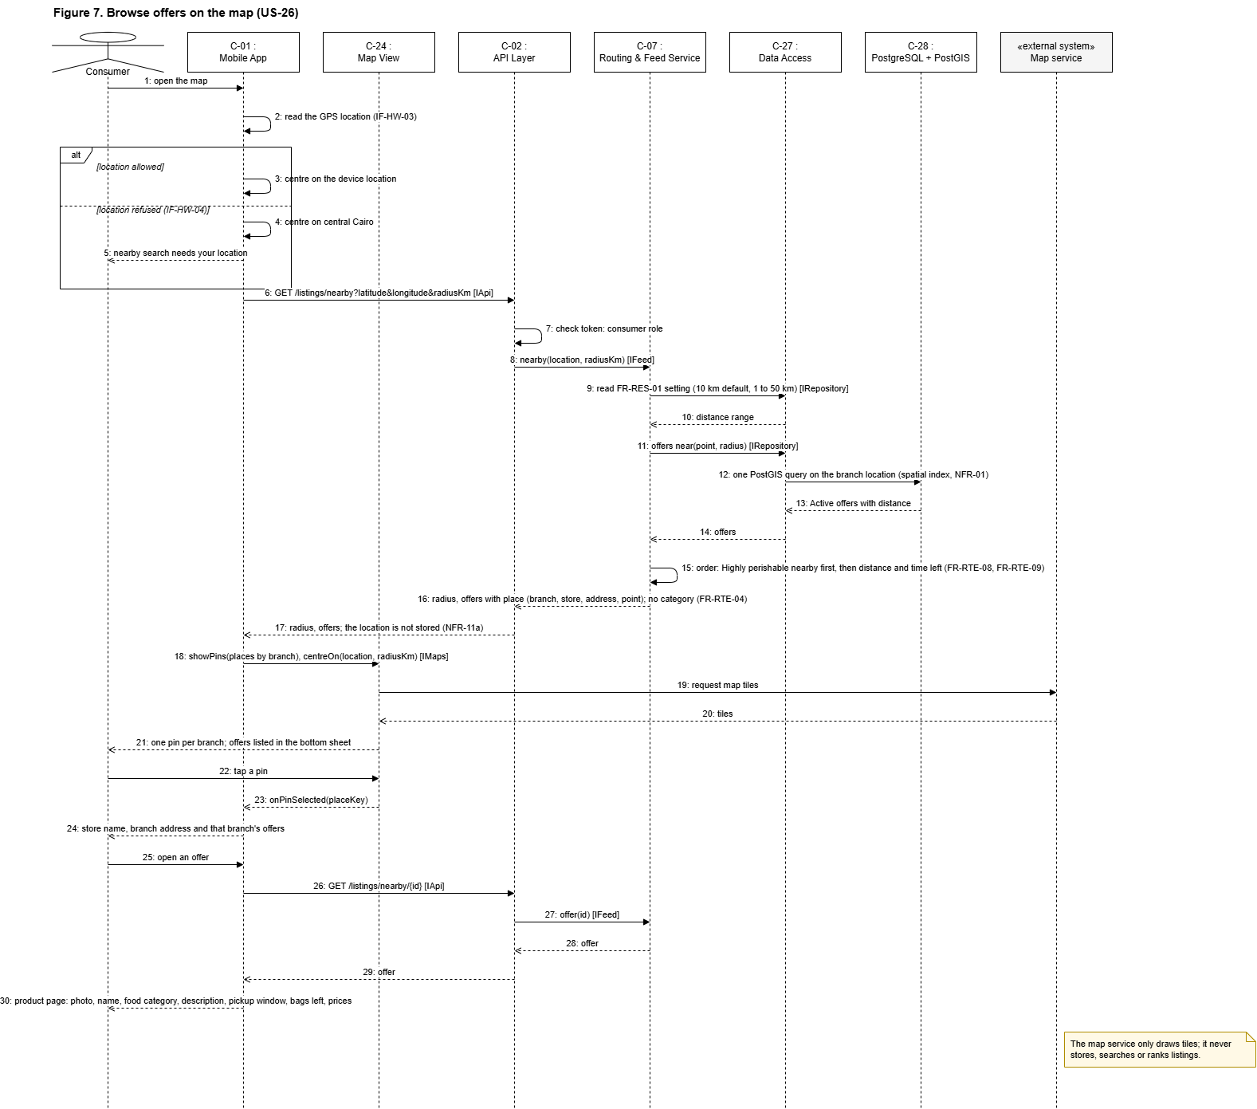

Figure 7. Browse listings on the map (US-26): the backend finds and orders the listings; the app draws their pickup points as pins.

The app sends the consumer's location to GET /listings/nearby. The Routing & Feed Service asks Data Access for the Active listings whose pickup branch is within the chosen distance (10 km by default); PostGIS answers with one indexed query (NFR-01). The service orders them and the API returns each listing with its branch's coordinates. The app passes the points to Map View, which draws one pin per branch on tiles from the external map service. The map service only draws; it never stores, searches or ranks listings.

3.2.5.4 Reserve a bag by card (US-27)

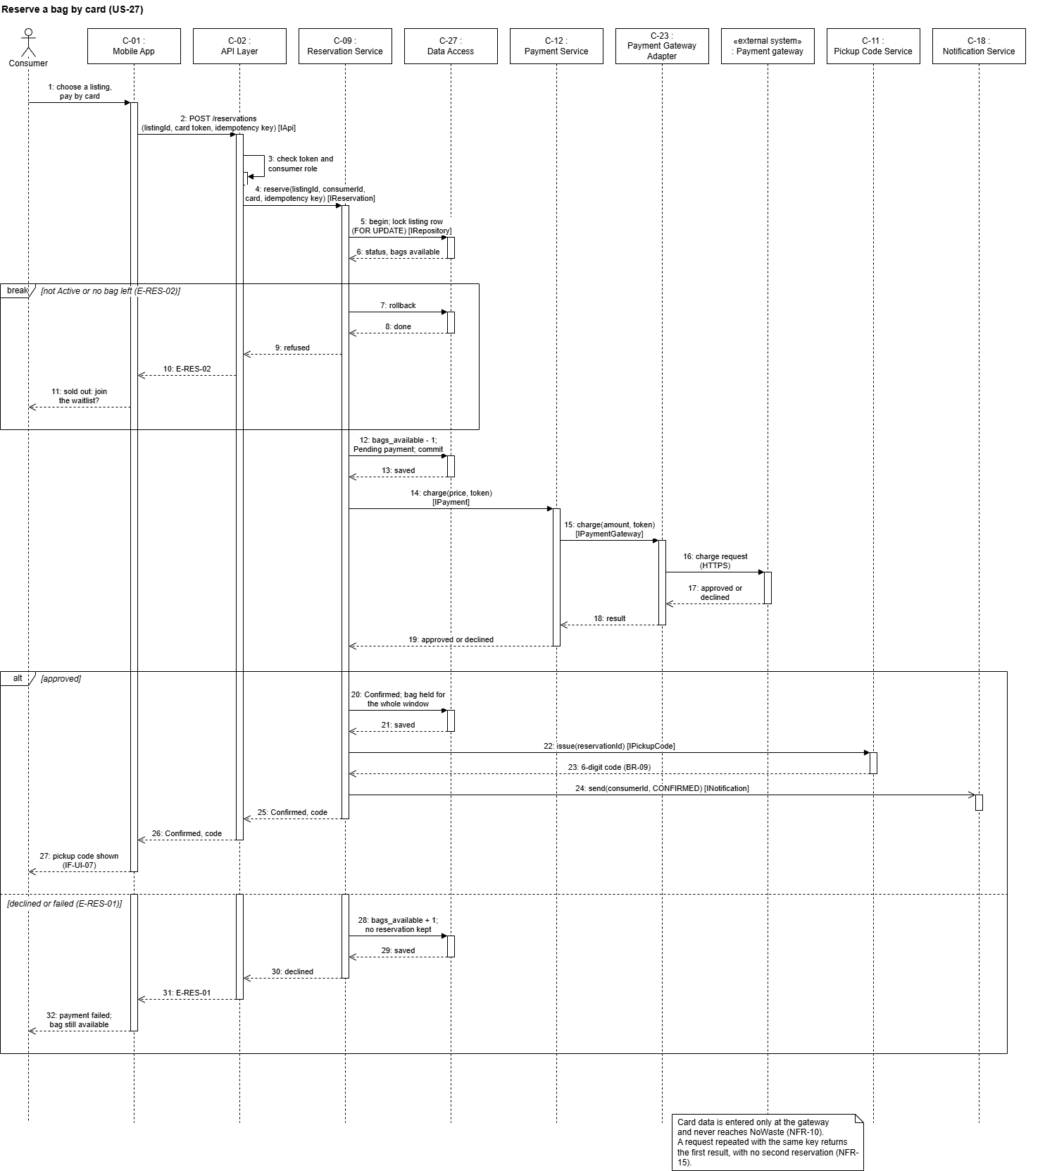

Figure 8. Reserve a bag by card (US-27): the listing row is locked so the last bag is sold once, and the reservation is confirmed only after the payment gateway approves.

The Reservation Service locks the listing row inside a transaction, so two consumers can never take the last bag (E-RES-02). It takes one bag, saves the reservation as Pending payment and commits, then charges the card through the Payment Service and the Payment Gateway Adapter. If the gateway approves, the reservation is Confirmed for the whole pickup window, a 6-digit pickup code is issued and a push notification is sent. If it declines or fails, the bag is put back and no reservation is kept (E-RES-01). Card data is entered only at the gateway and never reaches NoWaste (NFR-10).

3.2.5.5 No-card hold expires (US-28)
1. C-19 Scheduler / Worker checks the database every minute for Held reservations whose hold_expires_at has passed, measured by the server clock (IF-COM-07). No user and no API request is involved.
2. For these it calls C-09 Reservation Service: IReservation.releaseExpired().
3. C-09 marks each reservation No-show and records it through C-15: INoShow.record(reservation, HOLD_EXPIRED) (FR-RES-13). Three no-shows in 30 days block the consumer from no-card reservations.
4. C-09 releases the bag and calls C-18 Notification Service, INotification.send(consumer, RELEASED), which sends the push through C-25 Push Adapter.
5. If at least 30 minutes remain in the pickup window (BR-04), C-10 Waitlist Service offers the bag to the next consumer on the waitlist, who has 10 minutes to accept (BR-05); the Worker later expires that offer if it is not accepted (FR-RES-06). Otherwise the bag returns to the vendor (FR-RES-05).
6. Each job handles a due item once, with idempotent updates keyed on the stored time, so a restart of the Worker neither skips nor repeats a release (5.5).

3.3 Design Rationale

3.3.1 Why this structure
• Modular monolith, not microservices. A five-person student team, one semester, one database: a single deployable backend with clear modules is simpler to build, test and run. Modules match the SRS features, so they can be split later.
• Layered architecture. Separates screens, rules and data. Business rules (hold lengths, waitlist, refunds) live in one layer and are unit-tested without a database or network (NFR-13).
• One cross-platform client. React Native gives one codebase for Android and iOS with Arabic RTL support (NFR-06, NFR-14).
• Shared services for screens and assistant. The assistant calls the same services as the screens, so it follows the same rules and returns the same results (FR-AST-01, FR-AST-03).
• Separate worker with timers stored in the database. Timers keep running when no one calls the API and survive a restart; an API request is the wrong place to wait 10 minutes.
• Rules where predictability matters. Perishability, routing, discount suggestion and no-show counting are rule-based. AI is used only for photo classification, calorie estimates, the assistant and speech, and each has a fallback (NFR-03, NFR-05).
• PostgreSQL with PostGIS. Reservations, holds and receipts need transactions and row-level locking to prevent over-reservation, and PostGIS answers "within 10 km" searches in the database (NFR-01).

3.3.2 Patterns used
Pattern | Where | Why
Layered architecture | Whole backend | Separation of concerns, testability
MVVM | Mobile App | Screens (view), screen state (view model), API data (model); role-based screens and RTL
Adapter | C-20 to C-26, C-30 | Hides each provider's API; swap or mock without touching services
Facade | C-02 API Layer over the services | One entry point for the app, with authentication and RBAC in one place
Repository | C-27 Data Access | Keeps SQL out of services; easy to mock in tests
Strategy | Reservation method (card or no-card); routing ranking; discount formula | Same flow with interchangeable behaviour
State | Account, listing, reservation and partner offer lifecycles (3.2.2) | Makes allowed transitions explicit and testable
Observer (events) | Reservation released → Waitlist and Notification | Decouples services that react to the same event
Fallback (graceful degradation) | Every AI adapter and every external service | AI failure → manual listing, Highly perishable, normal screens; other services → functions that do not need them keep working (NFR-03, NFR-12)

3.3.3 Alternatives considered
Alternative | Why not chosen
Microservices | Too much deployment and testing overhead for this team and timeline
Native Android and iOS apps | Two codebases; conflicts with NFR-14
AI decides perishability end to end | A photo cannot show how long food has been out; rules plus vendor facts are safer and testable (NFR-05)
Distance calculation in the map service | An extra network call per search and a usage cost; PostGIS does it in the query (NFR-01)
Timers inside the API process | Lost on restart; a database-backed worker survives restarts
Storing photos in the database | Slows queries and enlarges backups

4. Data Design

4.1 Data Description
All structured data lives in PostgreSQL. Locations of vendors, branches and listings are PostGIS GEOGRAPHY(Point, 4326) columns with a spatial index, so "listings within 10 km" is one indexed query (NFR-01). A listing's location is its pickup point: the pin of the branch it is picked up from (D-64). A vendor's first branch is the shop pin set at registration (US-02); further branches have their own pins and opening hours. A Quick Post is picked up at the vendor's main branch. The map shows one pin per branch.
A vendor's and a partner's location is the pin they place on a map at registration, stored with a written address. Photos live in object storage (C-29); tables keep only the object key. A consumer's device location is sent with each search but never stored (NFR-11a), and no audio is stored (NFR-11b).
The backend is the single source of truth for bag counts, holds, waitlists and reservation status (IF-COM-06). Reserving a bag runs in one transaction that locks the listing row (SELECT … FOR UPDATE), so two consumers can never take the last bag (E-RES-02). Every timer is stored as a timestamp (hold_expires_at, offer_expires_at, pickup_end) measured by the server clock (IF-COM-07), so the worker can resume after a restart.
Rules live in the database, not in the code: the BR-01 limits and the other times and limits are rows of the settings table, and the shelf-life of each food category in each storage condition is a row of the perishability rules table (feedback change for US-18). The administrator will manage both (US-46, US-47).
Main relationships:
• User 1 → 0..1 VendorProfile or PartnerProfile (role-specific details).
• Vendor 1 → many VendorBranches; VendorBranch 1 → many Listings; Vendor 1 → many Listings; Listing 1 → many Reservations (at most bags_total active), many WaitlistEntries, many PartnerOffers.
• Reservation 1 → 0..1 Payment, 1 PickupCode, 0..1 Rating, 0..1 NoShow, 0..1 ZakatDonation.
• PartnerOffer 1 → 1 PickupCode once accepted.

4.2 Data Dictionary
Entity | Attributes (type) | SRS
User | id (UUID, PK); email (CITEXT, unique, nullable); phone (VARCHAR, unique, nullable; at least one of email or phone); password_hash (TEXT, salted hash); role (consumer, vendor, charity, composting, other, admin); status (Active, Pending, Approved, Rejected, Suspended, Removed); language (ar, en); no_card_blocked_until (TIMESTAMPTZ, nullable); flagged_for_admin (BOOLEAN); created_at | FR-ACC-01, NFR-09b, FR-RES-13, FR-TGI-04
VendorProfile | user_id (UUID, PK, FK); shop_name;address (TEXT, the written address beside the map pin); vendor_type (formal, informal); location (GEOGRAPHY); contact; auto_charity_opt_in (BOOLEAN); average_rating (NUMERIC); description (TEXT, nullable, up to 300 characters); opens_at, closes_at (TIME, Egypt time: the main branch's hours) | FR-ACC-02, FR-RTE-11, FR-TGI-02
VendorBranch | id (UUID, PK); vendor_id (FK); name (the shop name); address (TEXT); location (GEOGRAPHY, spatial index); opens_at, closes_at (TIME, Egypt time; a closing time earlier than the opening time means after midnight); created_at. The first branch is the shop itself | FR-ACC-02, FR-LST-01
PartnerProfile | user_id (UUID, PK, FK); organisation_name; partner_type (charity, composting, other); other_partner_type (TEXT, required for other); other_food_type (TEXT, nullable); accepted_food_types ("one or more values of the food_category type);"address (TEXT); location (GEOGRAPHY) | FR-ACC-03
FoodCategory (enumerated type) | bread_and_baked_goods, cooked_meals, fruit_and_vegetables, dairy_and_eggs, meat_poultry_and_fish, packaged_and_dry_food. One list used by partner profiles, listings and routing | Appendix A, FR-ACC-03, FR-RTE-05
Session | jti (UUID, PK, the access token's id); user_id (FK); created_at (TIMESTAMPTZ); ended_at (TIMESTAMPTZ, nullable, set at logout) | FR-ACC-04, IF-COM-03
LoginAttempt | id (BIGSERIAL, PK); user_id (FK); attempted_at (TIMESTAMPTZ); success (BOOLEAN) | NFR-09d, E-ACC-03
Listing | id (UUID, PK); vendor_id (FK); listing_type (Discounted Surplus Bag, Donation, Compost offer); status (Draft, Active, Fully reserved, Closed, Cancelled; Pending review and Rejected added with US-50); is_quick_post (BOOLEAN); food_type; name_ar, name_en, description_ar, description_en (the text as written, in one language; source_language ar or en); food_category (one of six, or NULL for Unknown); photo_key; calorie_min, calorie_max (nullable); bags_total, bags_available (INT); original_value (NUMERIC, nullable for Quick Post); price (NUMERIC, EGP); pickup_start, pickup_end (TIMESTAMPTZ); storage (room temperature, chilled, frozen, Unknown); prep_time and expiry_at (kept but no longer filled since D-64); perishability_category; unfit_for_people (BOOLEAN); location (GEOGRAPHY, the pickup point: the branch's pin); branch_id (FK to VendorBranch); created_at; planned with US-50: reviewed_by, reviewed_at, rejection_reason | FR-LST-01 to 07, FR-RTE-01 to 07
PerishabilityRule | food_category and storage (primary key together); shelf_life_hours (NUMERIC, nullable: not set gives Highly perishable); updated_at. Proposed values in SRS TBD-6 | FR-RTE-01, FR-ACC-10
Reservation | id (UUID, PK); listing_id (FK); consumer_id (FK); method (card, no-card); status (Pending payment, Confirmed, Held, Completed, Released, Cancelled, No-show); price_paid; hold_expires_at (nullable); checked_in (BOOLEAN); created_at | FR-RES-02 to 05, FR-RES-12
Payment | id (UUID, PK); reservation_id (FK); gateway_reference; amount (EGP); status (Approved, Declined, Refunded); refunded_at. No card data | FR-RES-02, NFR-10
PickupCode | id (UUID, PK); reservation_id or partner_offer_id (FK); code_hash; status (Active, Used, Void); used_at | FR-RES-10
WaitlistEntry | id (UUID, PK); listing_id (FK); consumer_id (FK); position; status (Waiting, Offered, Accepted, Expired); offer_expires_at | FR-RES-06
PartnerOffer | id (UUID, PK); listing_id (FK); partner_id (FK, nullable until accepted); status (Offered, Accepted, Completed, Cancelled); pickup_time; is_automatic (BOOLEAN) | FR-RTE-10 to 12
LandfillRecord | id (UUID, PK); listing_id (FK); bags (INT); recorded_at | FR-RTE-13
ZakatDonation | id (UUID, PK); reservation_id (FK); charity_id (FK); amount (EGP); receipt_number (unique); status (Paid, Delivered, Refunded); created_at; delivered_at | FR-TGI-05, FR-TGI-06
Rating | id (UUID, PK); reservation_id (FK, unique: one rating per Completed reservation); stars (1 to 5); review (TEXT, nullable); created_at | FR-TGI-01, E-TGI-01
NoShow | id (UUID, PK); reservation_id (FK, unique: a missed pickup counts once); consumer_id (FK); source (hold expired, cancelled after start, vendor flag); method (card, no-card); created_at | FR-RES-13, FR-TGI-03, FR-TGI-04
Notification | id (UUID, PK); user_id (FK); type; payload (JSON); sent_at; delivered (BOOLEAN) | FR-RES-11
BadBagReport | Planned for Sprint 3: id (UUID, PK); reservation_id (FK, unique: one report per reservation); consumer_id, vendor_id (FK); reason (TEXT); photo_key (nullable); status (Open, No action, Warned, Suspended); reviewed_by (FK, nullable); created_at | FR-TGI-09, FR-TGI-10
Settings | key (TEXT, PK); value (JSON); description; source. One row per business rule in SRS 5.5 (BR-01 to BR-12) and the rows Sprint 1 added: NFR-09d (login lockout), NFR-08a (photo size), FR-RTE-05 (partner distance), LOCAL-TIME (Africa/Cairo) and FR-RES-01 (search distance: 10 km by default, 1 to 50 km). Later: the automatic charity offer minutes (TBD-5), CO2 avoided per bag, iftar and suhoor times | BR-01 to BR-12, FR-TGI-07, FR-TGI-08

5. Component Design
The pseudocode below covers the components that carry the most SRS business rules. Times come from the settings table (SRS 5.5) and the server clock.

5.1 C-06 Perishability Service: estimate and pick-by time
estimate(foodCategory, storage, pickupStart, isQuickPost, aiConfident):
# FR-RTE-02, NFR-05d: missing or uncertain information -> most urgent
limit = foodLimit(foodCategory, storage, pickupStart, isQuickPost, aiConfident)
if limit is null: return HIGHLY_PERISHABLE
# FR-RTE-01: hours from the pickup start, or from now once the pickup has started
hours = hoursBetween(max(pickupStart, now()), limit)
if hours <= settings[BR-01].highly_perishable_max_hours: return HIGHLY_PERISHABLE
if hours <= settings[BR-01].short_life_max_hours: return SHORT_LIFE
return LONG_LIFE # how soon to collect, never "safe"
foodLimit(foodCategory, storage, pickupStart, isQuickPost, aiConfident):
shelfLife = perishability_rules[foodCategory, storage].shelf_life_hours # may be null
if isQuickPost or storage == UNKNOWN or foodCategory == UNKNOWN
or not aiConfident or shelfLife is null:
return null
return pickupStart + shelfLife hours
pickBy(inputs, branchClosesAt): # the latest pickup end
limit = foodLimit(inputs)
if limit is null: limit = pickupStart + settings[BR-01].highly_perishable_max_hours
return min(limit, branchClosesAt)
# The category is saved with the listing; the vendor does not change it.
# A pickup end the vendor chooses later than pickBy is refused with the latest allowed end (E-LST-03).

5.2 C-09 Reservation Service: reserve, check in, release, cancel
reserve(listingId, consumerId, method):
BEGIN TRANSACTION
listing = SELECT ... FROM listings WHERE id = listingId FOR UPDATE # E-RES-02
if listing.status != ACTIVE or listing.bags_available == 0: offer waitlist; fail
if method == NO_CARD and consumer.no_card_blocked_until > now():
fail with block end date, offer card payment # E-RES-04
listing.bags_available -= 1 # FR-RES-07, one bag
if listing.bags_available == 0: listing.status = FULLY_RESERVED
r = new Reservation(listingId, consumerId, method)
if method == CARD: r.status = PENDING_PAYMENT
else:
start = max(now(), listing.pickup_start)
r.hold_expires_at = min(start + 45 min, listing.pickup_end) # FR-RES-03
r.status = HELD
COMMIT
if method == CARD:
result = Payment.charge(listing.price, token)
if result == DECLINED: releaseBag(r); fail # E-RES-01
r.status = CONFIRMED # held for the whole window
PickupCode.issue(r); Notification.send(consumer, CONFIRMED)
checkIn(r): # FR-RES-04
if r.status != HELD or r.checked_in or now() > r.hold_expires_at: refuse # E-RES-05
r.hold_expires_at = min(r.hold_expires_at + 20 min, listing.pickup_end); r.checked_in = true
releaseExpired(): # run by the Worker
for r in Reservations where status == HELD and hold_expires_at < now():
r.status = NO_SHOW; NoShow.record(r, HOLD_EXPIRED) # FR-RES-13
releaseBag(r)
releaseBag(r): # FR-RES-05
Notification.send(r.consumer, RELEASED)
if listing.pickup_end - now() >= 30 min: Waitlist.offerNext(listing)
else: return the bag to the vendor
cancel(r): # FR-RES-12
if r.method == CARD and now() - r.created_at <= 10 min: Payment.refund(r.payment)
if r.method == NO_CARD and now() >= holdStart(r): NoShow.record(r, CANCELLED_AFTER_START)
r.status = CANCELLED; releaseBag(r)

5.3 C-10 Waitlist Service: offer the next person
offerNext(listing):
e = first WaitlistEntry where listing and status == WAITING
if e is null: return the bag to the vendor
e.status = OFFERED; e.offer_expires_at = now() + 10 min # FR-RES-06
Notification.send(e.consumer, WAITLIST_OFFER) # the offer also shows in the app (IF-SW-06)
expireOffer(e): # run by the Worker
e.status = EXPIRED; offerNext(listing)
accept(e, method):
if now() > e.offer_expires_at: refuse
e.status = ACCEPTED; Reservation.reserve(listing, e.consumer, method)

5.4 C-15 Rating & No-show Service: record a no-show
record(reservation, source):
# a missed pickup counts once, whoever records it first (unique reservation_id)
if NoShow exists for reservation: return
if source == VENDOR_FLAG and (now() < pickup_end or reservation.status == COMPLETED): refuse # E-TGI-01
insert NoShow(reservation, consumer, source, reservation.method)
# FR-TGI-04: every no-show counts toward the administrator flag
if count(NoShow for consumer in last 30 days) >= 3:
consumer.flagged_for_admin = true; Notification.send(admins, ACCOUNT_FLAGGED)
# FR-RES-13: the block counts only no-card no-shows
if count(no-card NoShow for consumer in last 30 days) >= 3:
consumer.no_card_blocked_until = now() + 14 days

5.5 C-19 Scheduler / Worker: jobs
The worker polls every minute and handles each due item once (idempotent updates keyed on the stored timestamp), so a restart neither skips nor repeats a job.
Job | When | Calls | SRS
Expire no-card holds | hold_expires_at passed | IReservation.releaseExpired | FR-RES-05, FR-RES-13
Expire waitlist offers | offer_expires_at passed | IWaitlist.expireOffer | FR-RES-06
Pickup window opens | pickup_start reached | INotification (bag ready) | FR-RES-11
Suggest a discount | deadline nearing with bags unreserved | IDiscount, INotification to the vendor | FR-LST-08
Automatic charity offer | the time the administrator sets (TBD-5) before pickup_end, vendor opted in, bags unreserved | IPartnerOffer.offer | FR-RTE-11
Window ended, nothing taken | pickup_end passed with no consumer or partner | INotification (ask the vendor to record landfill) | FR-RTE-13
Uncollected Zakat | pickup_end passed, donation not Delivered | IZakat.refundUncollected | E-TGI-03

6. Human Interface Design

6.1 Overview of the user interface
One app shows each role its own home screen after login (IF-UI-01). Every screen works in Arabic (right-to-left, mirrored) and English, and the language can be switched before registration (FR-ACC-09, IF-UI-02, IF-UI-03). The sign-up, browse and reserve flows work with TalkBack and VoiceOver, and text meets a 4.5:1 contrast ratio (NFR-07). The screens follow SRS 3.1:
Role | Main screens
Any user | Language selection, registration, login, password reset, profile, impact numbers
Consumer | Nearby listings on a map with a distance slider and in a list with filters; listing details; reserve (card or no card); my reservations with the pickup code, check-in and cancel; waitlist; rating; report a bad bag; donate as Zakat; AI assistant; Ramadan mode
Vendor | New listing (photo, AI draft, details, allowed pickup window, destination); Quick Post; my listings; branches and opening hours; reservations for a listing; enter pickup code; suggested discount; flag a no-show; automatic charity offers; landfill record; application status
Charity and composting partner | Application status; Donation or Compost offers; accept an offer and propose a pickup time; enter pickup code
Administrator | Pending applications; approve, reject, suspend or remove an account; listings waiting for approval; flagged accounts; bad-bag reports; perishability rules; business-rule settings

6.2 Screen images
Screen mock-ups will be added in a later sprint.

6.3 Screen objects and actions
• Map and list of listings: a distance slider (1 to 50 km, 10 km by default) that zooms the map; one pin per pickup branch, and the offers in a list that expands from the bottom of the screen; tapping a pin shows the store name, the branch address and that branch's offers, with a close button back to all offers; an offer opens the product page (photo, name, food category, description, pickup window, bags left, original price struck through next to the discounted price); filter drawer (distance, price, pickup time, vendor rating); each offer shows its pickup window, not the perishability category, and nothing says the food is safe (IF-UI-05, FR-RTE-04).
• Listing creation: camera or gallery photo; AI draft fields marked as drafts until the vendor confirms each one; calorie range labelled "Estimate" with a remove button (IF-UI-04, NFR-05b). The form shows the allowed pickup window ("Estimate: start to latest end") with the estimated category and its hours as the reason, and the vendor may choose an earlier end; after saving, the vendor sees the category with its hours and chooses the destination.
• Quick Post: photo, name and description, bags counter, price, optional food category, pickup start ("Now" unless a later time is chosen) and pickup end; the start must be within the opening hours and the end within the Highly perishable hours of the start.
• Administrator (Sprint 3): listings waiting for approval with Approve and Reject (with a reason); perishability rules and settings; bad-bag reports with No action, Warn and Suspend.
• Reserve: card or no-card choice; the no-card option shows the hold end time and the "I'm on my way" button; a blocked consumer sees the block end date and the card option (E-RES-04).
• My reservations: the 6-digit pickup code, shown from the local cache when offline (IF-UI-07, E-RES-06).
• Assistant: text box and microphone button; every reservation is repeated back with Confirm and Cancel buttons (FR-AST-03).
• Errors: the invalid field is highlighted with a message in the user's language (IF-UI-06).

7. Requirements Matrix
All 60 SRS functional requirements trace to at least one component. C-01 Mobile App supports every requirement as the user's screens and C-27 Data Access stores every one, so they are listed only where they do more than that. Section 3.2.5 walks through US-01, US-04, US-10, US-18, US-19, US-26, US-27 and US-28 component by component.

7.1 Functional requirements to components
FR | User story | Primary component | Supporting components
FR-ACC-01 | US-01 | C-03 Account | C-02
FR-ACC-02 | US-02 | C-03 Account | C-04
FR-ACC-03 | US-03 | C-03 Account | C-04
FR-ACC-04 | US-04 | C-02 API Layer | C-03
FR-ACC-05 | US-05 | C-03 Account | C-30
FR-ACC-06 | US-06 | C-03 Account
FR-ACC-07 | US-07 | C-04 Admin & Approval | C-18
FR-ACC-08 | US-08 | C-04 Admin & Approval | C-02, C-18
FR-ACC-09 | US-09 | C-01 Mobile App | C-03
FR-ACC-10 | US-46 | C-04 Admin & Approval | C-06, C-27
FR-ACC-11 | US-47 | C-04 Admin & Approval | C-19, C-27
FR-LST-01 | US-10 | C-05 Listing | C-26, C-29
FR-LST-02 | US-11 | C-05 Listing | C-06
FR-LST-03 | US-12 | C-05 Listing | C-20
FR-LST-04 | US-13 | C-05 Listing | C-06
FR-LST-05 | US-14 | C-05 Listing | C-09, C-12, C-18
FR-LST-06 | US-15 | C-05 Listing
FR-LST-07 | US-16 | C-05 Listing | C-20
FR-LST-08 | US-17 | C-08 Discount | C-19
FR-LST-09 | US-50 | C-04 Admin & Approval | C-05, C-18
FR-RTE-01 | US-18 | C-06 Perishability
FR-RTE-02 | US-18 | C-06 Perishability
FR-RTE-03 | US-18 | C-06 Perishability | C-05
FR-RTE-04 | US-18 | C-07 Routing & Feed | C-01
FR-RTE-05 | US-19 | C-07 Routing & Feed | C-27
FR-RTE-06 | US-19 | C-07 Routing & Feed
FR-RTE-07 | US-19 | C-07 Routing & Feed | C-13
FR-RTE-08 | US-20 | C-07 Routing & Feed | C-27, C-28
FR-RTE-09 | US-21 | C-07 Routing & Feed | C-27, C-28
FR-RTE-10 | US-22 | C-13 Partner Offer | C-11
FR-RTE-11 | US-23 | C-13 Partner Offer | C-19
FR-RTE-12 | US-24 | C-13 Partner Offer | C-11
FR-RTE-13 | US-25 | C-13 Partner Offer | C-16, C-19
FR-RES-01 | US-26 | C-07 Routing & Feed | C-24, C-28
FR-RES-02 | US-27 | C-09 Reservation | C-12, C-23
FR-RES-03 | US-28 | C-09 Reservation | C-19
FR-RES-04 | US-28 | C-09 Reservation
FR-RES-05 | US-28 | C-09 Reservation | C-10, C-19
FR-RES-06 | US-29 | C-10 Waitlist | C-18, C-19
FR-RES-07 | US-30 | C-09 Reservation | C-27
FR-RES-08 | US-31 | C-09 Reservation | C-01
FR-RES-09 | US-32 | C-09 Reservation
FR-RES-10 | US-33 | C-11 Pickup Code | C-13
FR-RES-11 | US-34 | C-18 Notification | C-19, C-25
FR-RES-12 | US-35 | C-09 Reservation | C-12
FR-RES-13 | US-35 | C-15 Rating & No-show | C-09, C-19
FR-AST-01 | US-36 | C-17 Assistant | C-07, C-21, C-22
FR-AST-02 | US-37 | C-17 Assistant | C-21, C-22
FR-AST-03 | US-38 | C-17 Assistant | C-09, C-12
FR-AST-04 | US-39 | C-17 Assistant | C-05, C-21
FR-TGI-01 | US-40 | C-15 Rating & No-show
FR-TGI-02 | US-40 | C-15 Rating & No-show | C-07
FR-TGI-03 | US-41 | C-15 Rating & No-show
FR-TGI-04 | US-42 | C-15 Rating & No-show | C-04, C-18
FR-TGI-05 | US-43 | C-14 Zakat & Receipt | C-09, C-12, C-13
FR-TGI-06 | US-43 | C-14 Zakat & Receipt | C-19
FR-TGI-07 | US-44 | C-16 Impact
FR-TGI-08 | US-45 | C-07 Routing & Feed | C-01
FR-TGI-09 | US-48 | C-15 Rating & No-show | C-18, C-26
FR-TGI-10 | US-49 | C-04 Admin & Approval | C-15, C-18

7.2 Nonfunctional requirements to architectural tactics
Each row names the claim, the architectural tactic that delivers it, the components that carry it and how it is verified, so a word such as available or reliable always points to a named mechanism and a test. The numbers stay in SRS Section 5.
NFR | Claim | Architectural tactic | Components | How we verify
NFR-01 Search speed | Nearby search answers quickly | One indexed PostGIS query per search; distances in the database, not in the map service | C-07, C-27, C-28 | Timed searches on a database of 500 listings
NFR-02 AI draft time | A slow AI never blocks posting | Time limit in the adapter; manual form as the fallback | C-20, C-05 | Timed photo set; forced timeout test
NFR-03 Availability (fault tolerance) | Vendors post and consumers search and reserve while the AI is down | One adapter per AI service with a timeout and a fallback; perishability and routing are rules, not AI | C-05, C-06, C-17, C-20 to C-22 | End-to-end demo with the AI credentials removed
NFR-12 Availability (external services) | Functions that do not need a failed service keep working | One adapter per external service with a timeout, error handling and a mock mode; statuses stay visible in the app without push | C-18, C-23 to C-26, C-30 | Switch each service off in turn and run the other functions
NFR-12 Availability (our own processes) | The API and the worker come back after a crash | API and worker run as separate processes restarted by the hosting platform; GET /health checks the database; timers are stored in the database, so nothing is lost on restart | C-02, C-19, C-28 | Stop each process and check the restart; health check test; worker restart test
NFR-08c Availability (offline) | An active reservation and its pickup code stay visible without a connection | Local cache in the app | C-01 | Load a reservation, switch to airplane mode and open it
NFR-15 Reliability | The same action gives the same result | Rule-based estimate and ranking from database rules, with no randomness; an idempotency key on POST /reservations; the worker handles each due item once, keyed on the stored time; one transaction with a row lock per reservation | C-06, C-07, C-09, C-19, C-27 | Repeated-input tests; duplicate-request test; worker restart test; concurrent last-bag test
NFR-05 Food safety | Food is never called safe, and a pickup window never passes the food limit | Pick-by time from the shelf-life rules and the branch closing time; Highly perishable by default; reviewed wording; the vendor confirms every AI field | C-01, C-05, C-06 | Tests named NFR-05; wording review in both languages
NFR-08a, NFR-08b Slow connections | Screens load on slow mobile data within the limit | Photos compressed on the device; small JSON payloads; timeouts with retry | C-01, C-02 | 5 MB photo test; loads on a simulated Fast 3G connection
NFR-09 Security | Only the right role can act, and passwords stay secret | HTTPS; JWT sessions ended at logout; RBAC in one place; login lockout; salted password hashes | C-02, C-03 | 403 test for every pair of roles; lockout test; database inspection
NFR-10 Card data | Card data never reaches NoWaste | Card details entered only at the gateway; the adapter receives only the result | C-12, C-23 | Database and log inspection after a sandbox payment
NFR-11 Privacy | Consumer location and voice are not stored | Location used only inside the request; audio deleted after processing | C-07, C-22 | Database and log inspection
NFR-04 Classifier accuracy | Drafts are useful | The provider behind the vision adapter is chosen and tested on the labelled photo set (TBD-2) | C-20 | Run on the 60 labelled photos
NFR-06, NFR-07 Arabic and accessibility | Every screen works right-to-left and with screen readers | All texts in Arabic and English through i18n; start and end layout instead of left and right; accessibility labels | C-01 | Screen checklist in both languages; screen-reader walkthrough
NFR-13 Maintainability | Changes are safe to merge | Layers and adapters testable with mocks; tests named with SRS IDs; GitHub Actions on every merge | All | Branch protection: a failing test blocks the merge
NFR-14 Portability | One codebase runs on Android and iOS | React Native with Expo | C-01 | Demo on one Android and one iOS device

8. Technical Risks and Appendices

8.1 Technical risks
ID | Risk | Impact | Mitigation
T-01 | AI classification below 80% accuracy (NFR-04) | Wrong drafts, vendor frustration | Vendor confirms every field; test early on the 60-photo set; low confidence routes to manual entry and Highly perishable; only the six food categories in SRS Appendix A
T-02 | AI uncertain or wrong about perishability | Pickup windows too long for the food | Rule-based estimate; Highly perishable by default; the pick-by time from the shelf-life rules caps the window; the vendor can only end earlier; no safety certification
T-03 | Two users reserve the last bag at once | Over-reservation (E-RES-02) | One transaction with a row lock on the listing; test with concurrent requests
T-04 | Timers missed or repeated after a restart | Bags stuck or released twice | Expiry times stored in the database; the worker polls and updates idempotently; restart test
T-05 | Payment sandbox limits (refunds, failures, Egyptian cards and wallets) | Payment and refund flows not fully testable | Choose a gateway with a sandbox early; mock gateway behind C-23; test refunds for cancelled listings and uncollected Zakat; the no-card flow works without the gateway
T-06 | Arabic speech recognition weak on Egyptian dialect | Assistant misunderstands requests | Assistant is an extra way to use the app (Medium and Low priority); typed fallback; every reservation is repeated for confirmation; test with Egyptian Arabic samples
T-07 | Slow connections (Fast 3G) | Slow uploads, failed calls (NFR-08) | Compress photos to 500 KB; small payloads; retries; cached reservations and pickup codes
T-08 | External API cost or rate limits (AI, language model, speech, email and SMS) | Features stop during the demo | Adapters with time limits and fallbacks; budget caps; mock adapters for development
T-09 | Push notifications not delivered | Missed 10-minute waitlist offers | Offers also shown in the app; the offer lives in the database, not only in the push (IF-SW-06)
T-10 | Location permission denied or inaccurate GPS | Wrong or no nearby results | Explain why location is needed (IF-HW-04); the map centres on central Cairo until a location is available; location used only for the request, never stored (NFR-11a)
T-11 | Role-based access mistakes | A user reaches another role's actions | RBAC in C-02 only; an automated 403 test for every pair of roles (NFR-09c)
T-12 | Voice recordings kept by the speech provider | Privacy breach (NFR-11b) | Choose a provider with no retention; delete audio after processing
T-13 | Android and iOS differences (RTL, TalkBack, VoiceOver) | Accessibility failures (NFR-06, NFR-07) | Test on both platforms from the first sprint; screen-by-screen checks in both languages
T-14 | Backend process crashes or hosting downtime | App cannot reach the API | Automatic restart policy and health check on both processes; cached reservations stay visible

8.2 Appendices
• Appendix A, Glossary: see SRS Appendix A; the terms specific to this document are in Section 1.5.
• Appendix B, Open design items: the open values in SRS Appendix C (TBD-1 to TBD-5) are settings in this design, not changes to the architecture: TBD-1 sets the minimum app versions, TBD-2 the provider behind each adapter, TBD-5 the automatic charity offer time and TBD-6 the shelf-life values (proposed values in use, waiting for team approval), all in the settings or rules tables.

